Assignment – 1

• Install Power BI Desktop and share the final screenshot of the report view page which appears when power desktop starts.

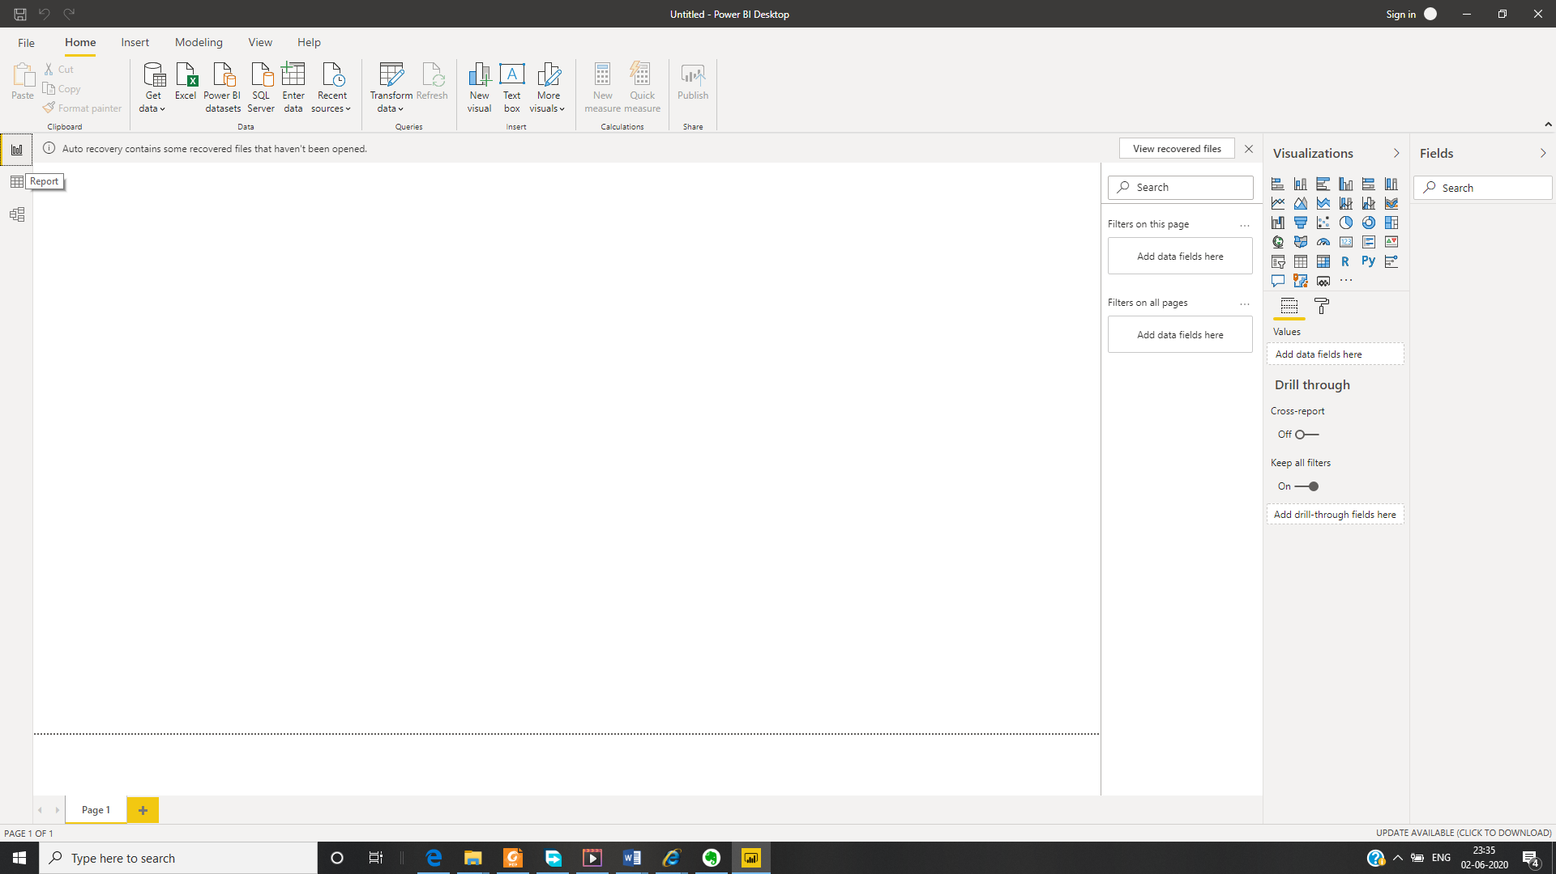

• Prepare a document and with the following screenshot- Report View



**- Data View**

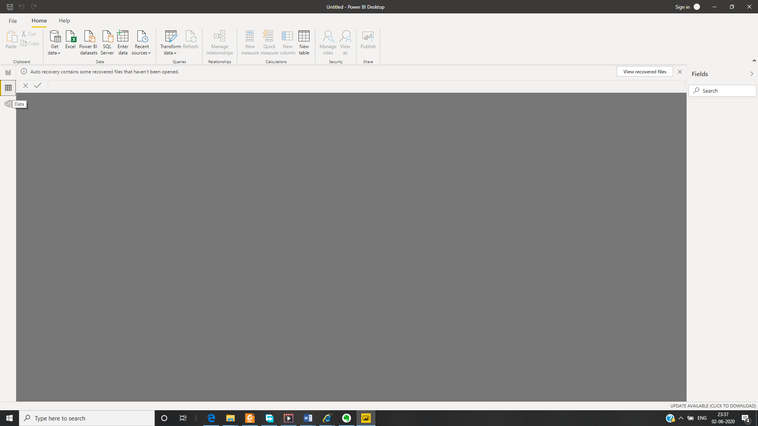

**- Model View**

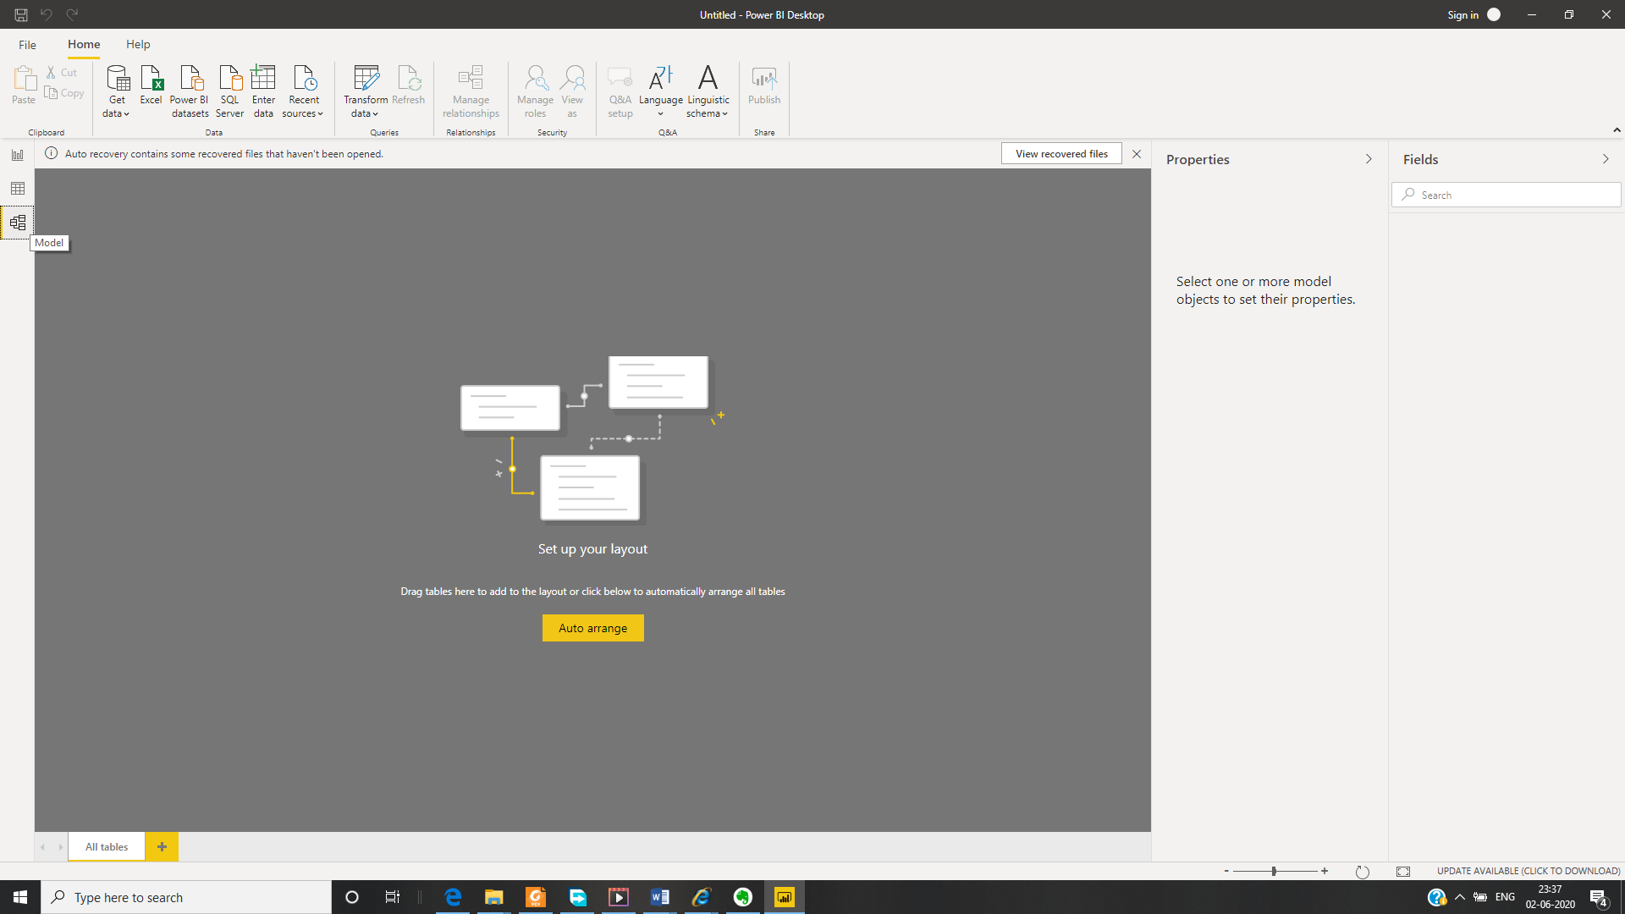

**- Power Query Editor**

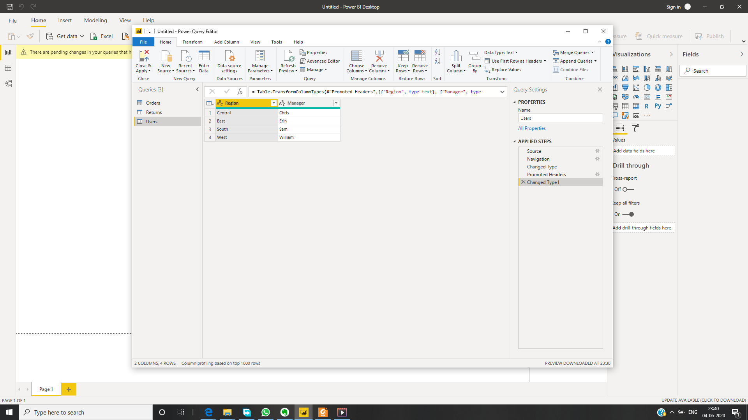

**- Advance Editor**

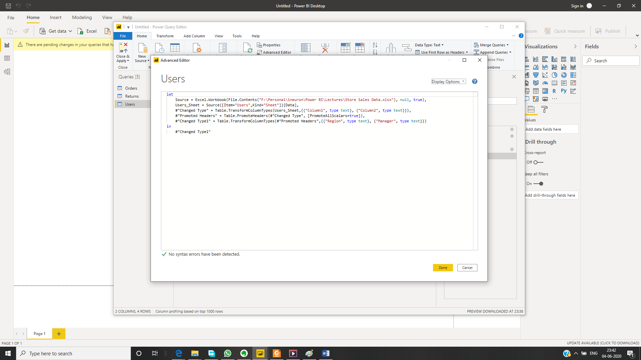

• Prepare a document with details of the following along with their price

Power BI consists of:

* A Windows desktop application called **Power BI Desktop**.
* An online SaaS (*Software as a Service*) service called the **Power BI service**.
* Power BI **mobile apps** for Windows, iOS, and Android devices.

**- Power BI Desktop**

Power BI is a free application to be install on local PC to connect, transform and visualize data connect single or multiple data sources and combine them. This process called data modelling. These models used to build visual report, which can shared with other working in your organization.

The most common uses for Power BI Desktop are as follows:

* Connect to data
* Transform and clean that data, to create a data model
* Create visuals, such as charts or graphs, that provide visual representations of the data
* Create reports that are collections of visuals, on one or more report pages
* Share reports with others by using the Power BI service

**Pricewise** it is a free to use with some limitations, but enough features to start with.

**- Power BI Pro**

Power BI Pro is an individual user licence to create, share and interact with other user reports and dashboard published on power Bi service. It’s a full version of power Bi.

A breakdown of Power BI Pro’s differences against Power BI Desktop:

* Ability to embed Power BI visuals into apps (PowerApps, SharePoint, Teams, etc)
* Native integration with other Microsoft solutions (Azure Data Services)
* Share datasets, dashboards and reports with other Power BI Pro users
* Can create App Workspaces and peer-to-peer sharing

The Pro plan **costs $9.99/user/month**. If you have 15-20 users, purchase Power Bi pro. For organisation, having more than 20 users it will be much costly. They can opt premium edition.

**- Power BI Premium**

Power BI Premium is a capacity-based offering that includes:

* Flexibility to publish reports broadly across an enterprise, without requiring recipients to be licensed individually per user.
* Greater scale and performance than shared capacity in the Power BI service.
* The ability to maintain BI assets on-premises with Power BI Report Server.
* One API surface, a consistent set of capabilities, and access to the latest features for embedded analytics.

Power BI users get

* Greater scale and performance
* Flexibility to license by capacity
* Unify self-service and enterprise BI
* Extend on-premises BI with Power BI Report Server
* Support for data residency by region (Multi-Geo)
* Share data with anyone without purchasing a per-user license

The **Premium** plan starts at **$4,995** a month per dedicated cloud compute and storage resource.